Exercise 1: Database searches (8p)
- Retrieve the protein sequence with accession number NP_081220.1 from the National Center for Biotechnology Information (NCBI) using their website at https://www.ncbi.nlm.nih.gov/ and its search functions. The sequence is from mouse (Mus musculus) and should be 286 amino acids long. Save it in a FASTA-formatted text file. Show the formatted sequence in the report. (1p)
>NP_081220.1 alpha-ketoglutarate-dependent dioxygenase alkB homolog 3 isoform a [Mus musculus]
MEDKRQRARVQGGWATPTKSQSATQPASPARSRLSQTAGPAWRSKEQQQCDRQFVFKEPQLVVRAAPEPR
VIDREGVYEISLSPTGVSRVCLYPGFVDLKEADWILEQLCKDVPWKQRMGIREDVTYPQPRLTAWYGELP
YTYSRITMEPNPHWLPVLWTLKSRIEENTSHTFNSLLCNFYRDEKDSVDWHSDDEPSLGSCPVIASLSFG
ATRTFEMRKKPPPEENGDYTYVERVKIPLDHGTLLIMEGATQADWQHRVPKEYHSRQPRVNLTFRTVYPD
PRGAPR
- Which variant of BLAST should be used to search the UniProKB/Swiss-Prot database with the retrieved sequence as the query? (1p)
BLAST P, because the query is a protein sequence containing aminoacids and the uniprokb/swiss-prot is a protein database.
- Use BLAST at https://blast.ncbi.nlm.nih.gov/Blast.cgi to search the UniProKB/Swiss-Prot database with the retrieved sequence as the query. Algorithm parameters must be adjusted as follows: “Expect threshold” = 10, "Word size" = 3, "Compositional adjustments" = "No adjustment" and Filter “Low complexity regions” = OFF. The scoring matrix should be BLOSUM62, and gap costs should be “Existence: 11 Extension: 1”. How many hits do youget? (1p) 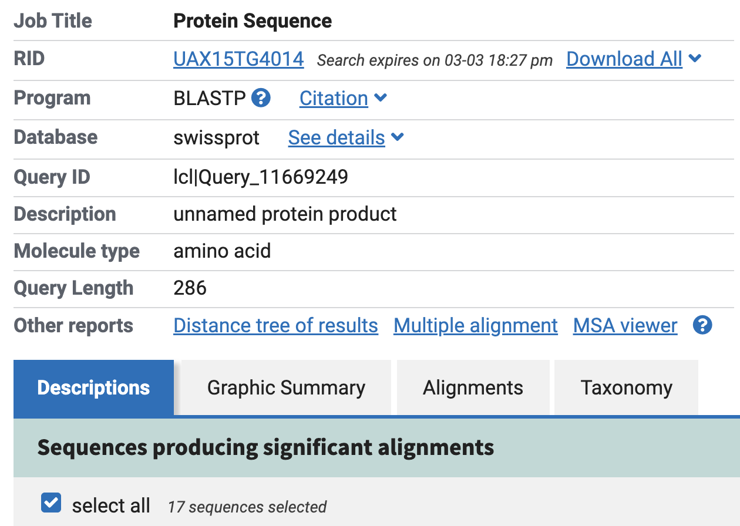
- What is the accession number (sequence id) of the best match with a sequence from Arabidopsis thaliana? Save the sequence in a file. (1p)
Q9SIE0.2

- Show the BLAST alignment between the query protein and the Arabidopsis thaliana protein. (1p)
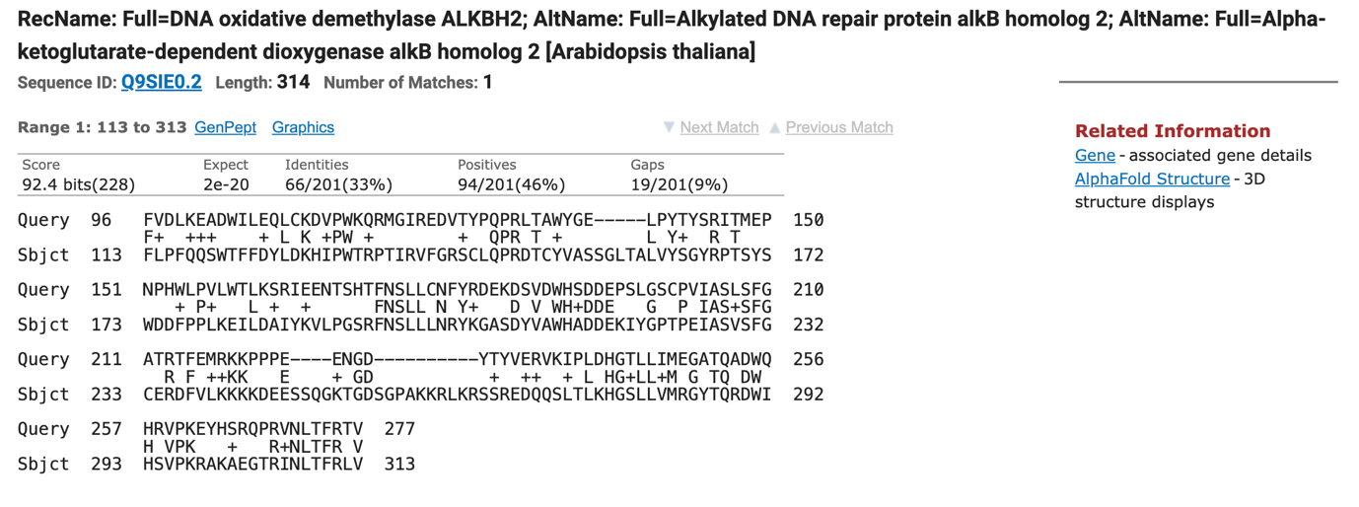
- What is the score (raw alignment score), the bit score and the E-value of this alignment? (3p)
Score: 92.4 bits(228)
E-Value: 2e-20

Exercise 2:

- Run your program on the mouse sequence and the Arabidopsis thaliana sequence. What score do you get? Show the alignment. (2p)
Best local alignment score: 228
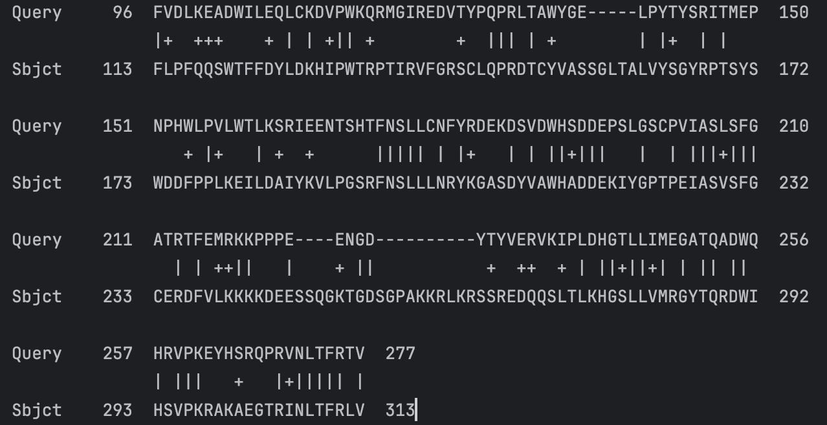
- Compare the score you got with the raw score from BLAST in exercise 1 and comment on any discrepancies. (2p)
Score from exercise 1: 92.4 bits(228)
Score from program: 228
- Compare the actual alignment you got with the alignment from BLAST and comment on any discrepancies. (2p)



- Retrieve the ALKB_ECOLI (P05050) sequence from Escherichia coli in FASTA format. Use your program to compare this sequence with the mouse sequence from exercise 1a. What score do you get? Show the alignment. Why did the sequence from E. coli not show up in the search in exercise 1? (4p)
Best local alignment score: 48
